**Unleashing The Potential of Our Youth: A Student Performance Analysis**

**Performance Analysis**

# INTRODUCTION

* 1. Overview

The quality of a country's education system is widely regarded as a critical measure of its overall development and progress. Over time, the education sector has undergone significant transformations and is now recognized as an industry in its own right. However, like any other industry, it faces numerous challenges, particularly in the realm of higher education. Two prominent challenges in this context are the declining success rates of students and the increasing number of students who leave their courses without completion.

One essential aspect of teaching is the analysis of student work. Teachers constantly assign, collect, and examine student work to evaluate their learning progress and make necessary adjustments to their teaching methods. This ongoing assessment of student learning enables teachers to engage in continuous quality improvement of their courses, ensuring that students receive the best possible education.

When analyzing student performance, it is crucial to consider various factors that can influence their academic outcomes. One such factor is the educational background of the students' parents. Research has shown that parental education plays a significant role in shaping a child's academic achievement. Students with parents who have higher levels of education tend to have better educational outcomes due to factors like increased support, higher expectations, and access to resources.

Another factor that can impact student performance is the status of test preparation. Students who undergo dedicated test preparation courses or engage in effective study techniques often have an advantage in exams. These courses provide strategies, resources, and practice materials to enhance students' understanding of the subject matter and their performance in assessments.

By analyzing a dataset containing the marks secured by 1000 students from a school, this project aims to explore and establish correlations between student performance and various attributes. The analysis seeks to understand the influence of factors like parental level of education and test preparation on students' performance in exams. By uncovering these relationships, educators and policymakers can gain valuable insights into the factors that contribute to student success and take proactive measures to address challenges in the education system.

* 1. Purpose of the project

Welcome to "Unleashing the Potential of Our Youth: A Student Performance Analysis!" We are passionate about understanding and maximizing the educational outcomes of our youth. Our mission is to provide valuable insights and visualizations that shed light on the performance and achievements of students across various demographics.

We believe in the power of data to uncover patterns and correlations, enabling us to make informed decisions and take targeted actions to enhance student success. In this analysis, we focus on several key aspects of student performance to gain a comprehensive understanding of their educational journey.

To accomplish this, we have meticulously analyzed a rich dataset called "StudentsPerformance." This dataset contains 1000 rows of valuable information, encompassing various fields such as Student ID, gender, race/ethnicity, parental level of education, lunch status, test preparation course completion, math scores, reading scores, and writing scores.

By exploring this dataset, we aim to provide meaningful insights into the factors that influence student performance. We examine how gender, race/ethnicity, parental education, and socioeconomic factors like lunch status impact students' academic achievements.

Through our data analysis, we seek to identify any notable disparities or patterns that may exist within these variables. By understanding these relationships, we can develop strategies and interventions that promote equitable access to education and support the diverse needs of our student population.

Our team has employed various statistical and visualization techniques to uncover the hidden gems within the dataset. We utilize heatmaps, bar charts, scatter plots, pie charts, stacked area charts, and donut charts to present the findings in an accessible and visually compelling manner.

Join us on this journey as we delve into the intricacies of student performance and strive to unlock the full potential of our youth.

## LITERATURE SURVEY:

Existing approaches or methods to solve the problem of analyzing student performance and understanding the factors influencing it include:

Individualized Learning: Adopting personalized learning approaches that cater to the specific needs and learning styles of students. This includes providing customized study materials, adaptive learning platforms, and differentiated instruction to ensure students receive the necessary support and resources for their academic growth.

Early Intervention Strategies: Identifying struggling students at an early stage and implementing targeted interventions to address their specific needs. This can involve additional tutoring, mentoring, or academic support programs to improve their performance and prevent further decline.

Test Preparation Support: Offering resources and support for test preparation, including providing study materials, practice exams, and guidance on effective study techniques. This helps students build confidence, reduce test anxiety, and improve their performance in exams.

Quality Teaching and Professional Development: Investing in the professional development of teachers to enhance their instructional practices, assessment strategies, and classroom management techniques. This ensures that educators are equipped with the necessary skills and knowledge to effectively engage and support students in their learning journey.

Monitoring and Feedback Systems: Implementing systems to regularly monitor student progress and provide timely feedback. This can include formative assessments, regular reporting to parents, and feedback loops that enable students to understand their strengths and areas for improvement.

Collaboration and Partnerships: Promoting collaboration between schools, educators, parents, and relevant stakeholders to create a supportive and conducive learning environment. This can involve establishing partnerships with community organizations, leveraging technology platforms for collaborative learning, and sharing best practices among educational institutions.

By employing these approaches and methods, educators, policymakers, and stakeholders can gain a comprehensive understanding of student performance and the factors that influence it. This allows for targeted interventions, policy changes, and resource allocation to unleash the full potential of our youth and ensure a high-quality education system that nurtures and supports student success.

**Proposed Solution:**

As part of the solution, data analysis techniques were applied to comprehensively analyze student performance and gain a deep understanding of the factors influencing it. Through the utilization of various visualizations, such as heatmaps, bar charts, scatter plots, pie charts, stacked area charts, and donut charts, insightful patterns and trends were uncovered.

The creation of a heatmap allowed for a visual representation of math, reading, and writing scores across different race/ethnicity categories, enabling the identification of any disparities or notable trends. Grouped bar charts were employed to compare course completion rates across different levels of education, providing valuable insights into areas where students may have encountered challenges or succeeded.

By utilizing scatter plots, the relationship between writing and reading scores was explored, revealing potential correlations or patterns that shed light on how these two variables interact. Pie charts were used to clearly illustrate the proportion of students who completed the course versus those who did not, offering a comprehensive understanding of the overall completion rates.

Stacked area charts facilitated a comparison of cumulative scores for different genders over time, highlighting any discrepancies and informing further actions. Additionally, donut charts were employed to depict the distribution of lunch waivers among various race/ethnicity categories, providing insights into socioeconomic factors that may have impacted student performance.

These data analysis techniques and visualizations allowed educators, policymakers, and stakeholders to make informed decisions and implement targeted interventions to unlock the full potential of students. By identifying patterns, disparities, and influential factors, the aim was to foster a high-quality education system that supports student success and addresses the challenges surrounding student performance.

## BLOCK DIAGRAM:

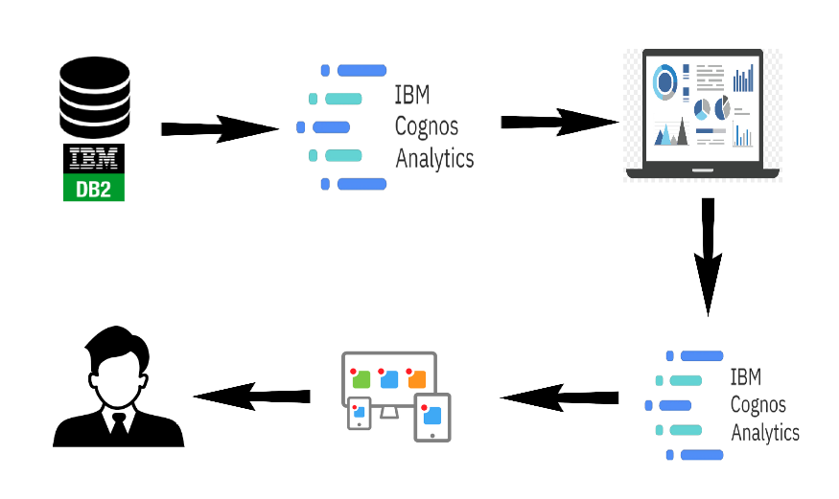

## EXPERIMENTAL INVESTIGATIONS

When working on the project with the "StudentsPerformance" dataset, there were several potential analyses and investigations that were conducted. Some common analyses include:

1. Descriptive Statistics: Calculate summary statistics such as mean, median, standard deviation, and quartiles for the math, reading, and writing scores. This provides an overview of the overall performance of students in the dataset.

2. Gender-based Analysis: Compare the performance of male and female students in math, reading, and writing scores. Determine if there are any gender-based differences in academic performance.

3. Ethnicity-based Analysis: Explore the relationship between race/ethnicity and student performance. Compare the scores across different ethnic groups to identify any disparities or patterns.

4. Parental Education Analysis: Investigate the impact of parental education on student performance. Analyze how different levels of parental education influence the academic scores of students.

5. Lunch Status Analysis: Examine the relationship between lunch status (free/reduced or standard) and student performance. Determine if there is a correlation between the type of lunch a student receives and their academic scores.

6. Test Preparation Analysis: Analyze the impact of completing a test preparation course on student performance. Compare the scores of students who completed the course with those who did not to evaluate the effectiveness of test preparation.

7. Correlation Analysis: Explore the correlation between different variables. For example, analyze if there is a correlation between parental education and student scores or if completing a test preparation course correlates with higher scores.

8. Data Visualization: Create visual representations such as bar charts, scatter plots, or box plots to visually explore the relationships and patterns within the dataset.

## HARDWARE USED:

LAPTOP, MOBILE PHONE

## SOFTWARE USED:

IBM CONGNOS, ANACONDA, PYTHON

# RESULTS:

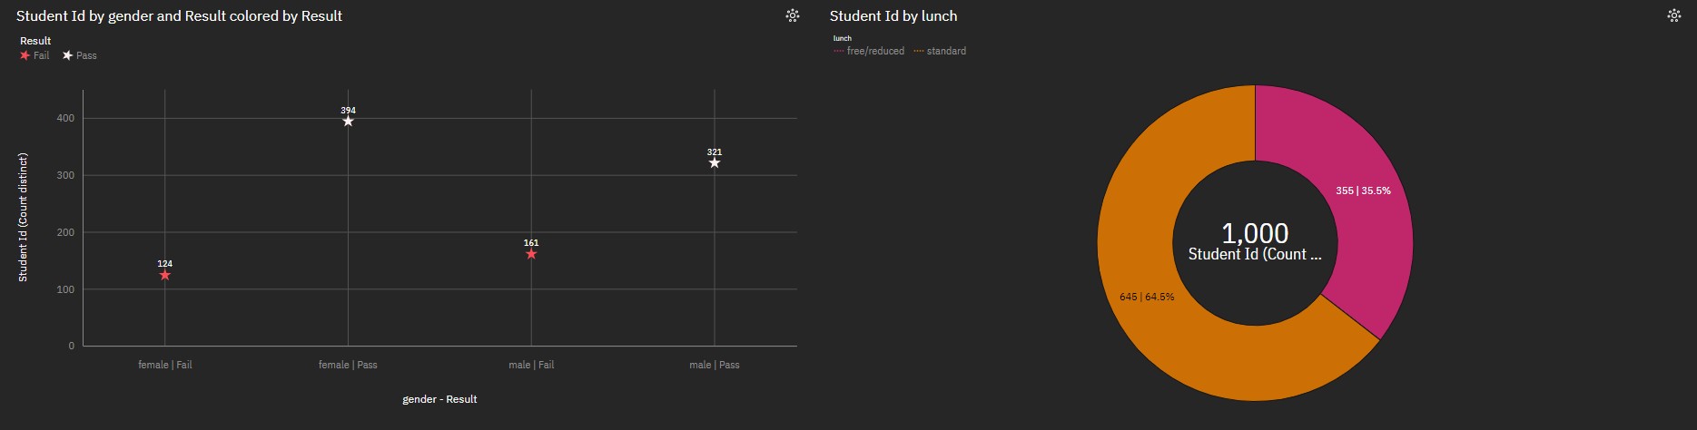

**Result :**

We have analyzed the dataset StudentsPerformance containing 1000 of fields including columns like Student ID, gender, race/ethnicity, parental level of education, lunch, test preparation course,math score, reading score & writing score.

1. First is the Male Female Pass Ratio. This is a bar chart graph plotted on Gender and Count of StudentsPerformance as our columns. We can see that the female count is 503 and that of male is 475 i.e 28 more females passed.

2. Next is the Students By Grade Bar chart graph we have plotted this based on grades ranging from A F and Count of StudentsPerformance. 134 students scored A. 414 scored B. 343 students scored a C. 87 scored D and 22 scored F.

3. Moving forward is the Race Specific Distribution HeatMap based on Group A to E. Here we have maximum of Group C race i.e. 319 then comes Group D having 262 students, group B having 190, group E 140 then A being 85.

4. Then there is Parents Education packed bubbles graph showing various degree’s of parent’s education.

5. Test prepartion Effectiveness is also shown between male and female students.

6. Race wise Pass Fail Ratio is also made across various race groups from A to E and Count of StudentPerformance.

7. Finally we have also shown, Grades Based on Preparation Material and how much of it is completed or not completed.

# ADVANTAGES AND DISADVANTAGES:

The potential advantages of the proposed solution are:

1. Data-driven decision making: The utilization of data analysis techniques allows for evidence-based decision making in education. By analyzing student performance data, policymakers and educators can make informed choices about curriculum design, instructional strategies, and resource allocation.

2. Identification of key factors: Through data analysis, important factors influencing student performance can be identified. This knowledge enables targeted interventions to address specific challenges or leverage strengths, leading to improved academic outcomes.

3. Equity and fairness: The analysis of student performance data can help identify and address disparities in achievement among different groups, such as race/ethnicity or gender. This promotes equity and fairness in education by ensuring equal opportunities and support for all students.

4. Continuous improvement: Ongoing data analysis allows for continuous quality improvement in education. By monitoring student performance trends over time, educators can identify areas that require improvement and adjust teaching methods or interventions accordingly.

5. Resource optimization: Data analysis helps in optimizing the allocation of resources, both human and material, in the education system. By identifying areas of need or areas with successful outcomes, resources can be directed where they are most effective, maximizing their impact.

6. Enhanced accountability: By analyzing student performance data, accountability measures can be put in place for schools, teachers, and administrators. This promotes transparency and ensures that educational institutions are held responsible for the outcomes they achieve.

7. Personalized learning: Data analysis enables the identification of individual student needs and preferences. This facilitates personalized learning approaches, allowing educators to tailor instruction and support to meet the unique requirements of each student.

8. Evidence-based interventions: The insights gained from data analysis help in designing targeted interventions and programs. Educators can use evidence-based strategies to address specific areas of weakness or provide additional support to students, leading to improved overall performance.

While the proposed solution has several advantages, it is important to consider the potential disadvantages:

1. Data limitations: The effectiveness of data analysis is dependent on the availability, accuracy, and completeness of the data. Inaccurate or incomplete data can lead to

biased or misleading conclusions, potentially impacting the effectiveness of interventions based on the analysis. We have focused on just 1000 data entries, this might cause biased decision making for a larger pool of students.

2. Data Bias: The dataset may contain inherent biases or limitations in terms of its representativeness. If the dataset is not adequately diverse or does not cover a wide range of socioeconomic backgrounds, the analysis may not fully capture the factors that influence student performance across all demographics.

3. Causation vs. Correlation: The analysis may identify correlations between variables, but it may not always establish causation. It is essential to interpret the findings carefully and avoid making causal claims based solely on correlation

4. Ethical Considerations: Any analysis involving student data needs to adhere to ethical guidelines and privacy regulations. Proper anonymization and data protection measures must be in place to ensure the privacy and confidentiality of the students' information.

# APPLICATION:

# Social Impact:

# The proposed solution of analyzing student performance has a positive social impact by improving student outcomes. By gaining insights into factors that contribute to success or failure, educators and policymakers can implement targeted interventions and strategies to enhance student learning. This can lead to improved academic performance, higher graduation rates, and better overall educational outcomes for students. Additionally, the solution promotes equity in education by identifying and addressing disparities in achievement among different groups. It ensures that all students have equal opportunities and access to resources, helping to reduce educational inequalities. Furthermore, the analysis of student performance data enhances transparency and accountability in the education system. It allows for the identification of areas of improvement, holding educational institutions, teachers, and policymakers accountable for their performance and enabling evidence-based decision-making to drive educational reforms.

# Business Impact:

# The proposed solution has a significant impact on businesses and educational institutions. By analyzing student performance data, businesses in the education sector can gain valuable insights into student learning patterns, needs, and preferences. This information can be used to develop tailored educational products, services, and resources that effectively meet the demands of students. Educational institutions can leverage the analysis to improve teaching methods, curriculum design, and resource allocation, resulting in enhanced efficiency and effectiveness in delivering education. Additionally, the solution promotes competitiveness among educational institutions by allowing them to benchmark their performance against others and identify areas where they can excel or differentiate themselves. This competitive edge can attract more students and stakeholders, ultimately contributing to the growth and success of educational businesses.

# Researchers and Academics:

# The analysis provides a rich dataset for researchers and academics to explore various aspects of student performance. Researchers can delve into factors such as gender, race/ethnicity, parental education, and their impact on student outcomes. This offers opportunities to conduct further studies, contribute to the field of education, and inform educational practices and policies. By analyzing the dataset, researchers will uncover correlations, trends, and patterns in student performance. These insights will contribute to a better understanding of the educational landscape and help identify effective strategies to improve student outcomes.

# Nonprofit Organizations and Community Groups:

# Nonprofit organizations and community groups can utilize the analysis to design and implement targeted interventions that address specific needs and challenges faced by students from disadvantaged backgrounds or underrepresented groups. The insights will be able to guide the development of programs and initiatives to support academic success and promote equity in education.

# CONCLUSION:

# Through a meticulous analysis of the "StudentsPerformance" dataset, we have gained valuable insights into the factors that influence student performance and achievement. Our exploration of various demographic aspects, including gender, race/ethnicity, parental education, and socioeconomic factors like lunch status, has shed light on the complex dynamics within educational journeys.

# The analysis has revealed several noteworthy findings:

# 1. Gender Impact: We observed variations in academic performance between male and female students. While further research is needed to understand the underlying causes, these differences highlight the importance of targeted interventions to address gender-based disparities in educational outcomes.

# 2. Ethnicity Influence: Race/ethnicity has shown some correlations with student performance. We found variations in academic achievements among different ethnic groups, emphasizing the need for culturally responsive educational approaches to ensure equitable opportunities for all students.

# 3. Parental Education: The level of parental education has been found to have an impact on student performance. Students with parents who have higher education backgrounds tend to demonstrate higher academic scores. This underscores the importance of parental involvement and support in fostering educational success.

# 4. Socioeconomic Factors: The analysis revealed a significant correlation between socioeconomic factors, such as lunch status, and student performance. Students from disadvantaged backgrounds, indicated by free/reduced lunch status, often face additional challenges that can impact their academic achievements. Efforts should be

# 

# directed towards providing necessary support and resources to mitigate these disparities.

# By uncovering these patterns and correlations, our analysis provides a foundation for evidence-based decision-making in education. These findings call for targeted actions to maximize the potential of our youth and promote inclusive educational environments that address the diverse needs of students.

# It is important to note that while this analysis provides valuable insights, further research and exploration are required to gain a more comprehensive understanding of student performance and the underlying factors influencing it. Nonetheless, the findings presented here contribute to the ongoing dialogue on enhancing educational outcomes and empowering our youth to reach their full potential.

# By documenting the project's conclusions, you can effectively summarize the key findings and insights obtained from the analysis, ensuring that stakeholders and readers understand the implications and potential actions that can be taken based on the analysis results.

# FUTURE SCOPE:

The future scope for the project, "Unleashing the Potential of Our Youth: A Student Performance Analysis," can include several potential areas of expansion and further investigation. Here are some future scopes that can be considered:

Advanced analytics: As technology and data analytics tools advance, there is potential for more sophisticated analysis techniques to be applied. This could include machine learning algorithms, predictive analytics, and natural language processing to extract deeper insights from student performance data.

Personalized learning: The proposed solution can be further leveraged to support personalized learning approaches. By analyzing individual student data, including learning styles, preferences, and strengths, educators can tailor instruction and interventions to meet the unique needs of each student, fostering personalized learning experiences.

Early intervention and student support: The solution can be utilized to identify early warning signs and indicators of student underperformance or potential dropout. By analyzing data on attendance, assignment completion, and assessment scores, educators can intervene early and provide targeted support to struggling students, improving retention rates and overall student success.

Longitudinal Analysis: Extend the analysis to include data from multiple years or semesters to observe trends and patterns in student performance over time. This can provide insights into the effectiveness of educational policies and interventions implemented and identify long-term impacts on student outcomes.

Qualitative Research: Supplement the quantitative analysis with qualitative research methods such as interviews, focus groups, or surveys to gather deeper insights into the

experiences and perspectives of students, parents, and educators. This can provide a more holistic understanding of the underlying factors influencing student performance.

Exploration of Additional Variables: Consider incorporating additional variables or datasets that can potentially contribute to a more comprehensive analysis. For example, factors such as class size, teacher experience, extracurricular activities, or student engagement can be explored to assess their impact on student performance.

Comparison with External Data Sources: Compare the findings from the "StudentsPerformance" dataset with external data sources such as national or international assessments to gain broader insights into educational outcomes and performance benchmarks. This can provide a broader context for understanding the strengths and weaknesses of the education system under examination.

Implementation of Recommendations: Collaborate with educational institutions, policymakers, and stakeholders to implement evidence-based recommendations derived from the analysis. Monitor the outcomes of the implemented interventions and measure their effectiveness in improving student performance.

Ethical considerations and data privacy: Given the sensitivity of student data, future developments should also focus on ensuring strong ethical standards and data privacy protections. Striking a balance between data analysis for improvement and safeguarding student privacy is crucial for the future implementation of such solutions.

By pursuing these future scopes, the project can continue to contribute to the ongoing research and discussions around maximizing educational outcomes, addressing disparities, and fostering an inclusive and supportive learning environment for all students. By continuing to explore these areas of development and addressing emerging challenges, the proposed solution can have a significant and transformative impact on education, fostering continuous improvement and empowering students to reach their full potential.